**Code Smells**

# Long Parameter List

The following 3 examples of this code smell are all found in the **preferences** package located in “src/main/java/org/jabref/preferences”.

GuiPreferences.java

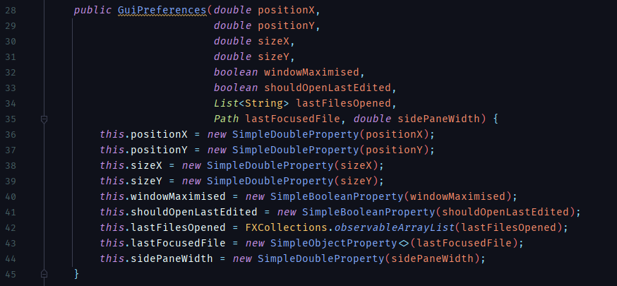

ImportExportPreferences.java

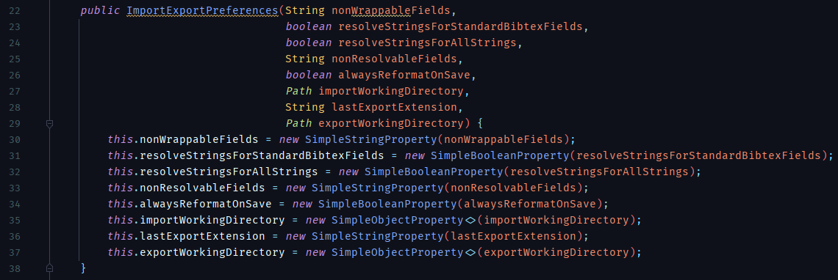

ExternalApplicationsPreferences.java

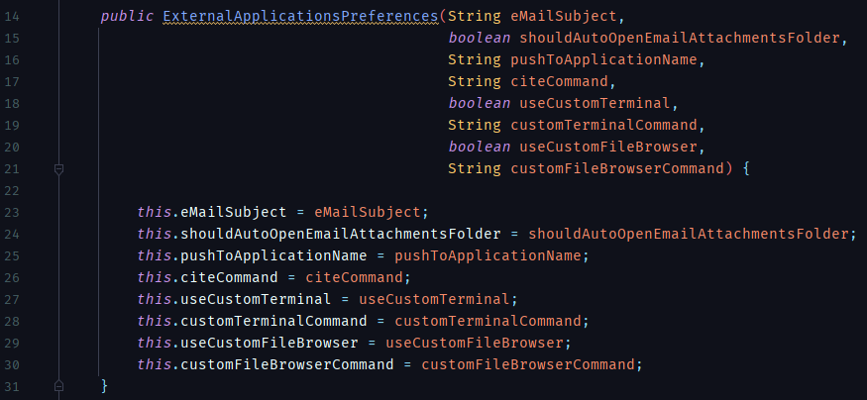

**Fix:** Either bundling some arguments together inside an immutable class (for example the position and size parameters in the **GuiPreferences** constructor), passing the caller class as a parameter, or, passing as parameters the instances that contain the variables listed as parameters in these constructors.

# Long Method

src/main/java/org/jabref/gui/groups/GroupDialogViewModel.java

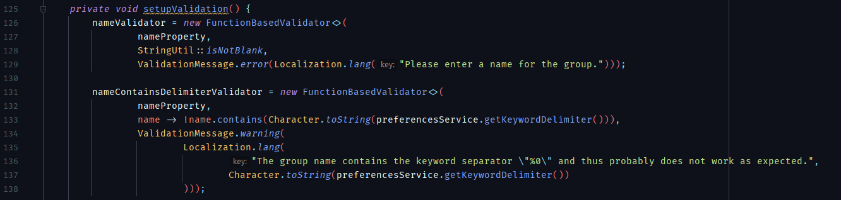

…

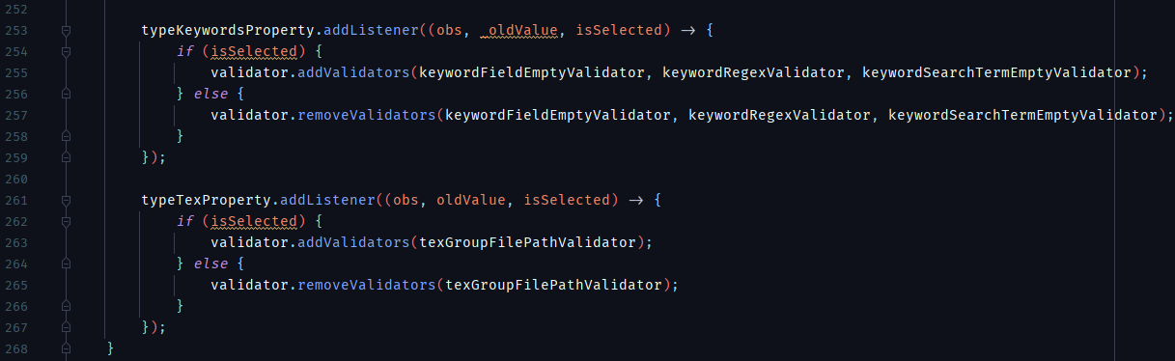

**Fix:** With a total of 143 lines, this method could be greatly improved by, for example, separating the logic for the assignment of each **Validator** instance variable into different methods, which would then be called by the main **setupValidation()** method.

# Comments/Dead Code

src/main/java/org/jabref/gui/groups/GroupTreeViewModel.java

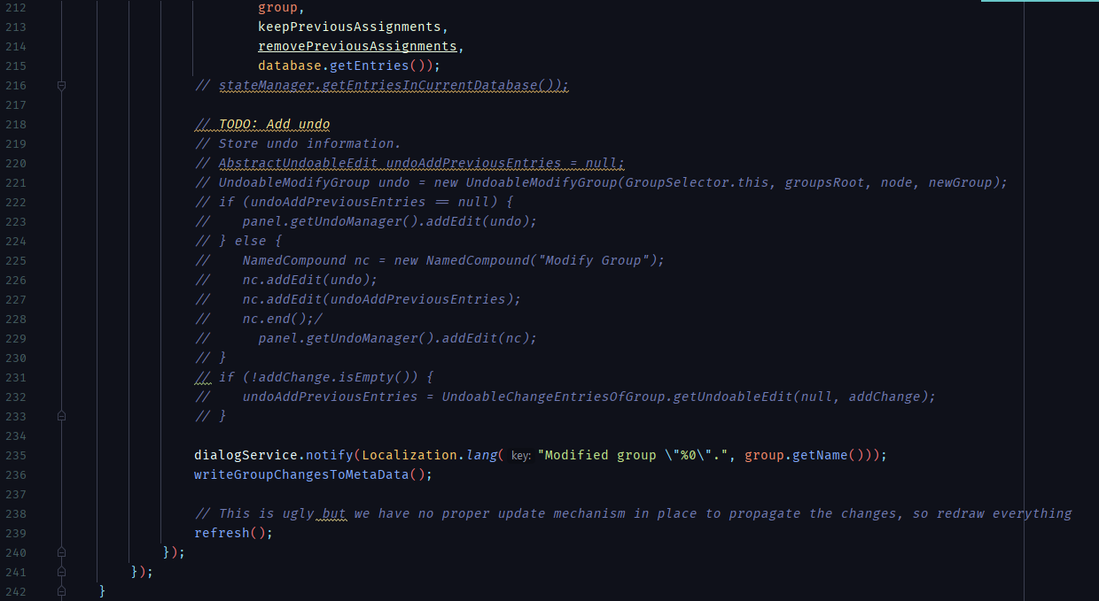

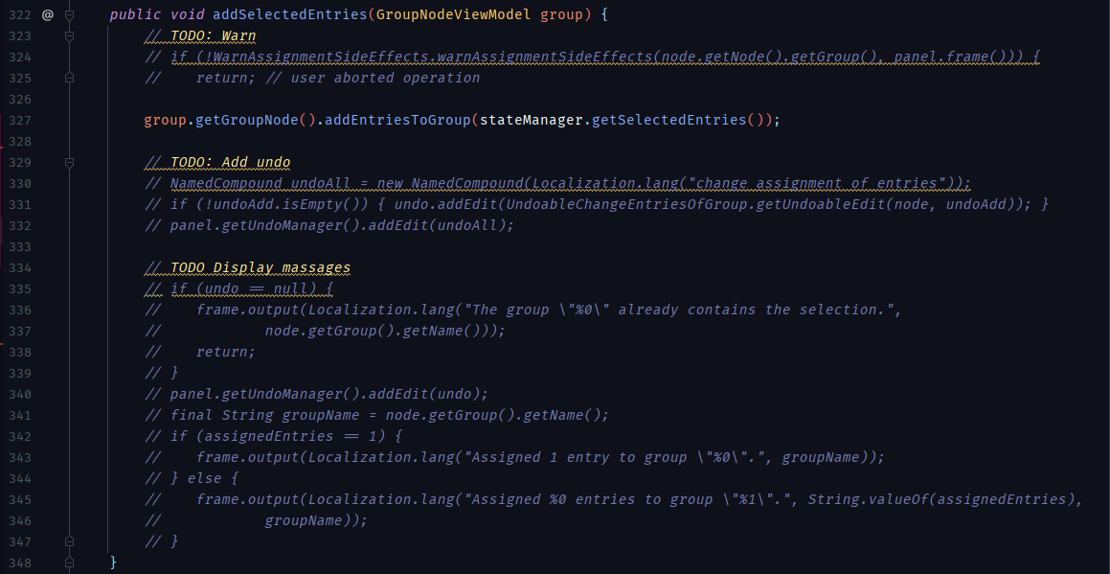

**Fix:** Deletion. If the code had/has to be altered, the previous/current implementation should be discarded and reimplemented in a new commit, there is no use for commenting out previous/temporary code that doesn’t work, as well as comments that indicate problems with the current implementation in the code itself, as seen in line 238.